MATH3070Assignment_5

## Assignment 5

NOTE: I have omitted most of your code from the output of this RMarkdown file in order to save space, as I didn’t think it would be useful for you to re-read your own code. I have just included the relevant chunks for each question, as well as my own bits of code.

## INFORMTION ABOUT THE MODEL

We are using cesm_rcp85, which is a GCM (General Circulation Model), with greenhouse gas forcing under RCP8.5 (high emissions), from 2006-2100.

The integrated primary production comes from a biogeochemical model (for nutrients and phytoplankton) forced by the GCM.

## [1] 360 180 1140

Note that the dimensions of the SST array are: [360, 180, 1140]. These represent 360 deg longitude, 180 deg latitude, and 1140 months between jan 2006 and dec 2100

## Q1. Plotting sea surface for Dec 2006 and Dec 2100

# Plot SST for Dec 2006  
plot1 <- ggplot(data = df, aes(x = Lon, y = Lat, fill = SST_2006)) +   
 geom_raster() + scale_fill_gradientn(colours = matlab.like(12), guide = "colorbar", na.value = "gray") +   
 theme_bw() + labs(fill = "") + ggtitle("SST Dec 2006")  
  
# Plot SST for Dec 2100  
plot2 <- ggplot(data = df, aes(x = Lon, y = Lat, fill = SST_2100)) +   
 geom_raster() + scale_fill_gradientn(colours = matlab.like(12), guide = "colorbar", na.value = "gray") +   
 theme_bw() + labs(fill = "") + ggtitle("SST Dec 2100")  
  
grid.arrange(plot1, plot2, ncol=1)

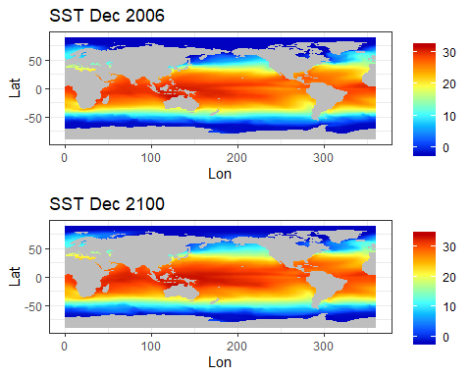From these plots we can see a global increase in temperature, in some regions more than others. To look at these changes more closely, I plot the difference in sea surface temperature from 2006 to 2100.

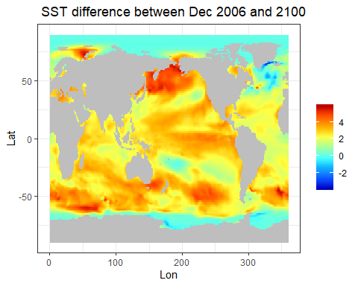# Plot SST difference between Dec 2006 and 2100  
ggplot(data = df, aes(x = Lon, y = Lat, fill = SST_2100 - SST_2006)) +   
 geom_raster() + scale_fill_gradientn(colours = matlab.like(12), guide = "colorbar", na.value = "gray") +   
 theme_bw() + labs(fill = "") + ggtitle(" SST difference between Dec 2006 and 2100")

Here we can see increases of at least 4 degrees centigrade in places such as the south-eastern coast of Australia and around the top of Asia.

#compute average temperature increase in sea surface and atmosphere  
ss =mean(df$SST_2100 - df$SST_2006, na.rm=T)  
ss

## [1] 2.282163

a = ss*1.5  
a

## [1] 3.423244

I also calculated the mean increase in global temperature from 2006 to 2100. This was 2.28 deg (3 sf) for the sea surface, and then I multiplied this by 1.5 to estimate the increase in atmospheric temperature, which was 3.42 deg (3 sf).

We now investigate the effects this has on how fast the phytoplankton are growing, i.e. the primary production.

# IntPP = Integrated Primary Production  
IntPP_nc <- open.nc("cesm_rcp85_intpp_zint_monthly_200601-210012.nc") # Primary production  
IntPP <- var.get.nc(IntPP_nc, 'intpp') # Extract intpp data from intpp_nc  
  
df$IntPP_2006 <- as.vector(IntPP[,,12]) # Dec 2006  
df$IntPP_2100 <- as.vector(IntPP[,,1140]) # Dec 2100  
  
# Plot SST for Dec 2006  
plot3 <- ggplot(data = df, aes(x = Lon, y = Lat, fill = IntPP_2006)) +   
 geom_raster() + scale_fill_gradientn(colours = matlab.like(12), guide = "colorbar", na.value = "gray") +   
 theme_bw() + labs(fill = "") + ggtitle("Integrated primary production Dec 2006")  
  
# Plot SST for Dec 2100  
plot4 <- ggplot(data = df, aes(x = Lon, y = Lat, fill = IntPP_2100)) +   
 geom_raster() + scale_fill_gradientn(colours = matlab.like(12), guide = "colorbar", na.value = "gray") +   
 theme_bw() + labs(fill = "") + ggtitle("Integrated primary production Dec 2100")  
  
grid.arrange(plot3, plot4, ncol=1)

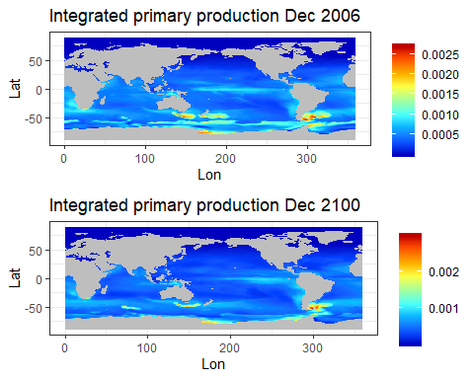

# Calculate mean difference in primary production  
ppchange =mean(df$IntPP_2100 - df$IntPP_2006, na.rm=T)  
ppchange

## [1] -3.955745e-05

From these maps we can see a general decrease in primary production, especially in coastal areas. I calculated the mean change in pp and found an average decrease of 3.955745e-05 mmolC/m^2/s globally, which is 41.01316 mgC/m^2/d for each meter sq grid of ocean as viewed by a satellite.

## Q2. Estimating total fish biomass in the world

# Total fish catch in tonnes  
format(Biom_year[1], scientific = TRUE) # total biomass in 2006

## [1] "4.944208e+09"

format(Biom_year[15], scientific = TRUE) # total biomass in 2020

## [1] "4.760608e+09"

format(Biom_year[95], scientific = TRUE) # total biomass in 2100

## [1] "3.763634e+09"

Jennings et al. (2008) estimated the fish biomass would be 7.91 x 10^8 tonnes in 2020. Our estimate for the year 2020 was 4.76 x 10^9 tonnes. Possible reasons for why these two estimates differ are: **INSERT REASONS HERE**

size classes of fish, we’ve just lumped them all together

## Q3. Sensitivity analysis

First, we vary alpha and keep all other parameters constant

#Varying alpha, everything else remains constant  
Beta <- 1000 # Predator Prey Mass Ratio  
E <- 0.63 # Activation energy  
k_b <- 8.62e-05 # Boltzmann's constant  
K <- SST + 273.15 # Temperature in Kelvin  
W_min <- 1 # Minimum mass  
W_max <- 1e6 # Maximum mass  
  
# Alpha = Trophic transfer efficiency  
  
Avec = c(0.05, 0.125, 0.2)  
BioVec = rep(0,3)  
  
for (i in c(1,2,3))  
{  
 A = Avec[i]  
 P_Wm <- (exp(25.22 - E/(k_b*K))*W_m^0.75)/365 # Abundance of phytoplankton  
 N_Wm <- PP_Wm/P_Wm # Abundance of phytoplankton at Wm  
 b <- log10(A)/log10(Beta)-0.75 # Slope of size spectrum  
 a <- N_Wm/(W_m^b) # Intercept of size spectrum  
 Biom_conc <- (a/(b+1))*(W_max^(b+1) - W_min^(b+1))  
 Biom_conc <- Biom_conc/10^6 # Convert to tonnes/m^3  
 Area_grid <- t(as.matrix(area(raster())))*1000*1000  
 Biom_total <- sweep(Biom_conc, c(1,2), Area_grid, '*')  
 Biom_month <- apply(Biom_total, 3, sum, na.rm = TRUE)  
 Biom_year <- colMeans(matrix(Biom_month, 12)) # Total global biomass in each year  
   
 TotalBio = format(Biom_year[15], scientific = TRUE) # total biomass in 2020  
 BioVec[i] = TotalBio  
}  
  
print(BioVec)

## [1] "9.258305e+07" "4.760608e+09" "4.009353e+10"

plot(Avec,BioVec,  
 type="l",  
 main="Total Global Fish biomass vs Alpha values",  
 ylab="Biomass", xlab="Trophic Transfer Efficiency")

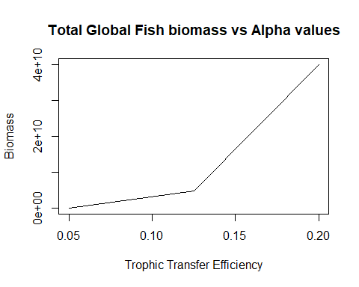

We now vary beta, and keep all other parameters constant.

#Varying alpha, everything else remains constant  
Alpha <- 0.125 # Predator Prey Mass Ratio  
E <- 0.63 # Activation energy  
k_b <- 8.62e-05 # Boltzmann's constant  
K <- SST + 273.15 # Temperature in Kelvin  
W_min <- 1 # Minimum mass  
W_max <- 1e6 # Maximum mass  
  
  
Bvec = c(10, 100, 1000, 10000)  
BioVec = rep(0,4)  
  
for (i in c(1,2,3,4))  
{  
 B = Bvec[i]  
 P_Wm <- (exp(25.22 - E/(k_b*K))*W_m^0.75)/365 # Abundance of phytoplankton  
 N_Wm <- PP_Wm/P_Wm # Abundance of phytoplankton at Wm  
 b <- log10(Alpha)/log10(B)-0.75 # Slope of size spectrum  
 a <- N_Wm/(W_m^b) # Intercept of size spectrum  
 Biom_conc <- (a/(b+1))*(W_max^(b+1) - W_min^(b+1))  
 Biom_conc <- Biom_conc/10^6 # Convert to tonnes/m^3  
 Area_grid <- t(as.matrix(area(raster())))*1000*1000  
 Biom_total <- sweep(Biom_conc, c(1,2), Area_grid, '*')  
 Biom_month <- apply(Biom_total, 3, sum, na.rm = TRUE)  
 Biom_year <- colMeans(matrix(Biom_month, 12)) # Total global biomass in each year  
   
 TotalBio = format(Biom_year[15], scientific = TRUE) # total biomass in 2020  
 BioVec[i] = TotalBio  
}  
  
print(BioVec)

## [1] "3.20533e+02" "5.550369e+07" "4.760608e+09" "5.049508e+10"

## First I did a normal plot, but then decided a log transformation for the x-axis would be better  
  
# plot(Bvec,BioVec,  
# type="l",  
# main="Total Global Fish biomass vs Beta values",  
# ylab="Biomass", xlab="PPMR")  
  
plot(Bvec,BioVec,  
 type="l",  
 main="Total Global Fish biomass vs Beta values",  
 ylab="Biomass", xlab="PPMR",  
 log = "x")

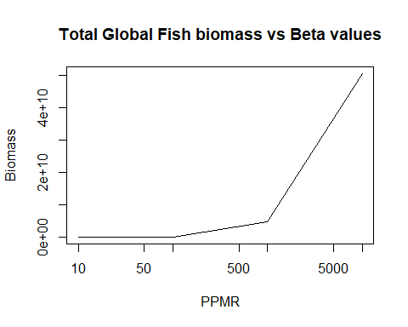

And finally, we vary E, and keep all other parameters constant.

#Varying alpha, everything else remains constant  
Alpha <- 0.125 # Predator Prey Mass Ratio  
Beta <- 1000 # Activation energy  
k_b <- 8.62e-05 # Boltzmann's constant  
K <- SST + 273.15 # Temperature in Kelvin  
W_min <- 1 # Minimum mass  
W_max <- 1e6 # Maximum mass  
  
  
Evec = c(0.6,0.63,0.66,0.69)  
BioVec = rep(0,4)  
  
for (i in c(1,2,3,4))  
{  
 En = Evec[i]  
 P_Wm <- (exp(25.22 - En/(k_b*K))*W_m^0.75)/365 # Abundance of phytoplankton  
 N_Wm <- PP_Wm/P_Wm # Abundance of phytoplankton at Wm  
 b <- log10(Alpha)/log10(Beta)-0.75 # Slope of size spectrum  
 a <- N_Wm/(W_m^b) # Intercept of size spectrum  
 Biom_conc <- (a/(b+1))*(W_max^(b+1) - W_min^(b+1))  
 Biom_conc <- Biom_conc/10^6 # Convert to tonnes/m^3  
 Area_grid <- t(as.matrix(area(raster())))*1000*1000  
 Biom_total <- sweep(Biom_conc, c(1,2), Area_grid, '*')  
 Biom_month <- apply(Biom_total, 3, sum, na.rm = TRUE)  
 Biom_year <- colMeans(matrix(Biom_month, 12)) # Total global biomass in each year  
   
 TotalBio = format(Biom_year[15], scientific = TRUE) # total biomass in 2020  
 BioVec[i] = TotalBio  
}  
  
print(BioVec)

## [1] "1.389399e+09" "4.760608e+09" "1.634157e+10" "5.619556e+10"

plot(Evec,BioVec,  
 type="l",  
 main="Total Global Fish biomass vs E values",  
 ylab="Biomass", xlab="Activation Energy")

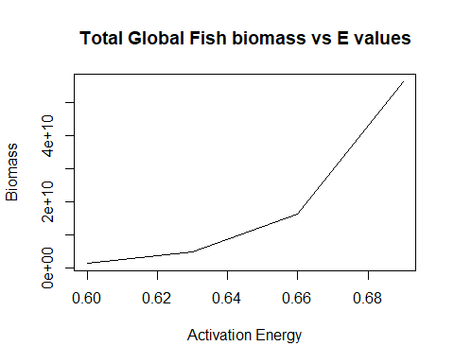

EXPLAIN WHAT IS HAPPENING HERE, COMMENT ON EACH OF THE GRAPHS

## Q4: What will happen to fish biomass in the future?

## Global time series

Firstly we calculate the percentage change in fish biomass from 2006, and plot this as a global time series.

# Plot relative change in % over 21st century  
Years <- 2006:2100  
PercChange <- 100*(Biom_year/Biom_year[1])-100 # % Change each year compared with 2006  
  
plot(Years, PercChange, type = 'l', lwd = 1.2,   
 ylab = '% Change',  
 xlab = 'Year',   
 main = 'Change in Total Consumer Biomass \n under RCP8.5')

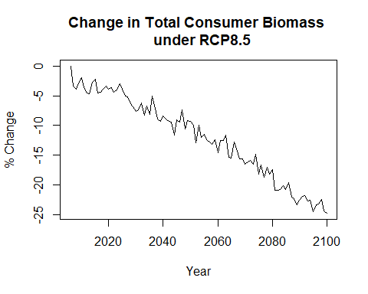

## Change in biomass from the 2010s to the 2090s

Here, we calculate the percentage change in fish biomass between the 2010s and 2090s

# Calculate % change in biomass between 2010s and 2090s  
Biom_2011_2020 <- apply(Biom_conc[,,61:180], c(1,2), mean, na.rm = TRUE)  
Biom_2091_2100 <- apply(Biom_conc[,,1021:1140], c(1,2), mean, na.rm = TRUE)  
  
#Biom_change = Change in biomass between 2011-2020 and 2091-2100 for each 1 deg grid of the world  
Biom_change <- 100*(Biom_2091_2100/Biom_2011_2020)-100  
  
### NOTE: I changed the comparison data from 2006-2015 to 2011-2020 so we can accurately talk about the 2010s as a complete decade

We check the raw distribution of % changes in biomass from 2010s to 2090s, and modify any outliers.

hist(Biom_change, xlim=c(-100,100), ylim=c(0,30000),   
 xlab="% change", main="Raw distribution of % changes in biomass", breaks=5)

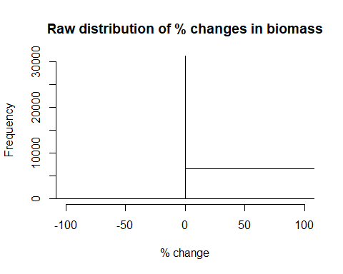

# Modify high outliers, everything above + or -50%   
Biom_change[Biom_change > 50] <- 50  
Biom_change[Biom_change < -50] <- -50

We now use ggplot to plot these changes on a map.

## GLOBAL MAPS OF FISH BIOMASS  
## Use ggplot to make plot map of change in fish biomass  
Biom_frame <- expand.grid(Lon = Lons, Lat = Lats)  
Biom_frame$Biom_change <- as.vector(Biom_change)  
  
ggplot(data = Biom_frame, aes(x = Lon, y = Lat, fill = Biom_change)) +   
 geom_raster() + scale_fill_gradientn(colours = rev(matlab.like(12)), guide = "colorbar", na.value = "gray") +   
 theme_bw() + labs(fill = "") + ggtitle("Fish biomass change 2090s - 2010s")

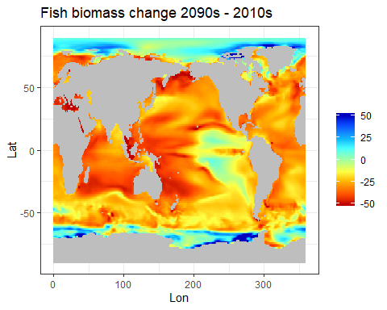

From this map we can see major decreases in fish biomass all over the globe, especially in coastal areas. In many areas we can expect that by the end of the century, the total catch of fish will be as low as half of what it currently is. This could have disasterous consequences for the human population both in terms of food shortages and economic stability, since many fisheries will no longer be profitable, and so these businesses will close and people will lose their jobs.

However, from the map, we also notice that in the areas near to the poles, there are increases in fish biomass. This may suggest that fish will migrate to these colder climates when their own habitat becomes too hot for them to thrive. As a result, we may see more fisheries open in these areas of the globe, if they become habitable and we build civilisations here.

## Q5: Countries/regions most affected by climate change

WRITE UP THIS QUESTION

Coastal countires, Australia, Mediterranean, Indonesia, Eastern coast of Africa, North eastern Russia.

Also increases in antartica and north coast of greenland. Send big fishing vessels out here?

WRITE ABOUT EFFECTS ON LIVELIHOODS

## Q6: Global rate of decline in fish per degree c of warming

SST_month <- colMeans(SST,na.rm=TRUE, dims=2)  
SST_year <- colMeans(matrix(SST_month, 12))  
SSTChange <- SST_year - SST_year[1]  
  
plot(Years, SSTChange, type = 'l', lwd = 1.2, lty = 1,  
 ylab = 'Temperature Change',  
 xlab = 'Year',   
 main = 'Global change under RCP8.5')  
par(new=TRUE)  
plot(Years, PercChange, type = 'l', col="red", lty = 2, xlab="", ylab="", yaxt = "n", xaxt="n" )  
axis(side=4)  
mtext("% change in biomass", side = 4, line = -1)  
legend("left", c("SST change", "Biomass % change"),  
 col = c("black", "red"), lty = c(1, 2))

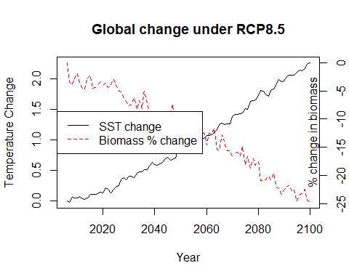

#   
# plot(Years, AtmosphericChange, type = 'l', lwd = 1.2,   
# ylab = 'Temperature Change',  
# xlab = 'Year',   
# main = 'Global atmospheric temperature change')  
  
plot(SSTChange, PercChange,  
 ylab = '% change in biomass',  
 xlab = 'Sea surface temperature warming',   
 main = 'Change in Biomass vs. Change in temperature')

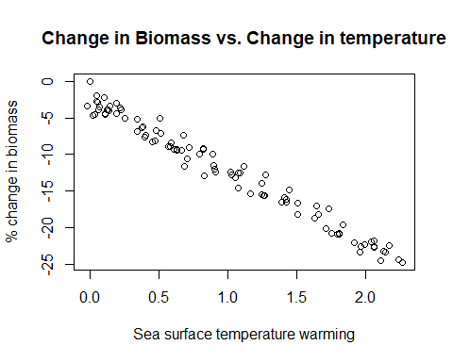

# plot(Years, SSTChange, type = 'l', lwd = 1.2, lty = 1,  
# ylab = 'Temperature Change',  
# xlab = 'Year',   
# main = 'Climate change under RCP8.5')  
# par(new=TRUE)  
# plot(Years, Biom_year, type = 'l', col="red", lty = 2, xlab="", ylab="", yaxt = "n", xaxt="n" )  
# axis(side=4)  
# mtext("% change", side = 4, line = 2)  
# legend("left", c("SST change", "Fish Biomass"),  
# col = c("black", "red"), lty = c(1, 2))